# IU Verse

IU is caring.

* [Sharing ice cream](https://www.facebook.com/photo.php?fbid=650154417712475&set=a.117886170939305&type=3)
* [When Life Gives You Tangerine](https://x.com/heyattidude/status/1901802064327626845).

A message to my friends.

The following message was sent to

Maggie Huang, SHEILA (WSB Financial Service), Peter Lac, Tiffany Lac, Alfred from Six Flags in Costumes, Waylen (Berkeley graduate and firefighter), WL (Sunday Stroller), Deanna from Thailand, Jerry from Original Buffalo Wings), Hein (my brother-in-law from Intel), Micheal Ng (from Nvidia and UC Davis CS) my longest and closest friend, Paul Wen (UC Davis cs), Vincent Chen (UC Davis UC), and Shawn Carolane of Menlo Ventures).

# Fond moment

The fondest moment I could ever imagine was my three months as intern in Symantec QA on Visual Café. 1996. My days in Six Flags ain’t that bad. Four years of back-to-back stage performance and growth.

* [My days](https://x.com/ChrisWillx/status/1901619527382966334)



Figure . I am goddess. You are chop liver.

# Lewis Howes

* [Book tour](https://fb.watch/ym-TJn_V1l/)

My brother did sent me $300 allowance. I am not sure if he’ll send again, so after spending four hours to take Bart, I got a heavy-duty staple gun from Home Depot. I will print 20 copies per day (max allowance) in the library and plaster Ads on the light posts every day. It is raining in the Bay Area, so I might have to wait a week. Lewis Howe’s show is this Sunday.

Needless to say. I did not code today.

Figure . Lewis Howes's book tour

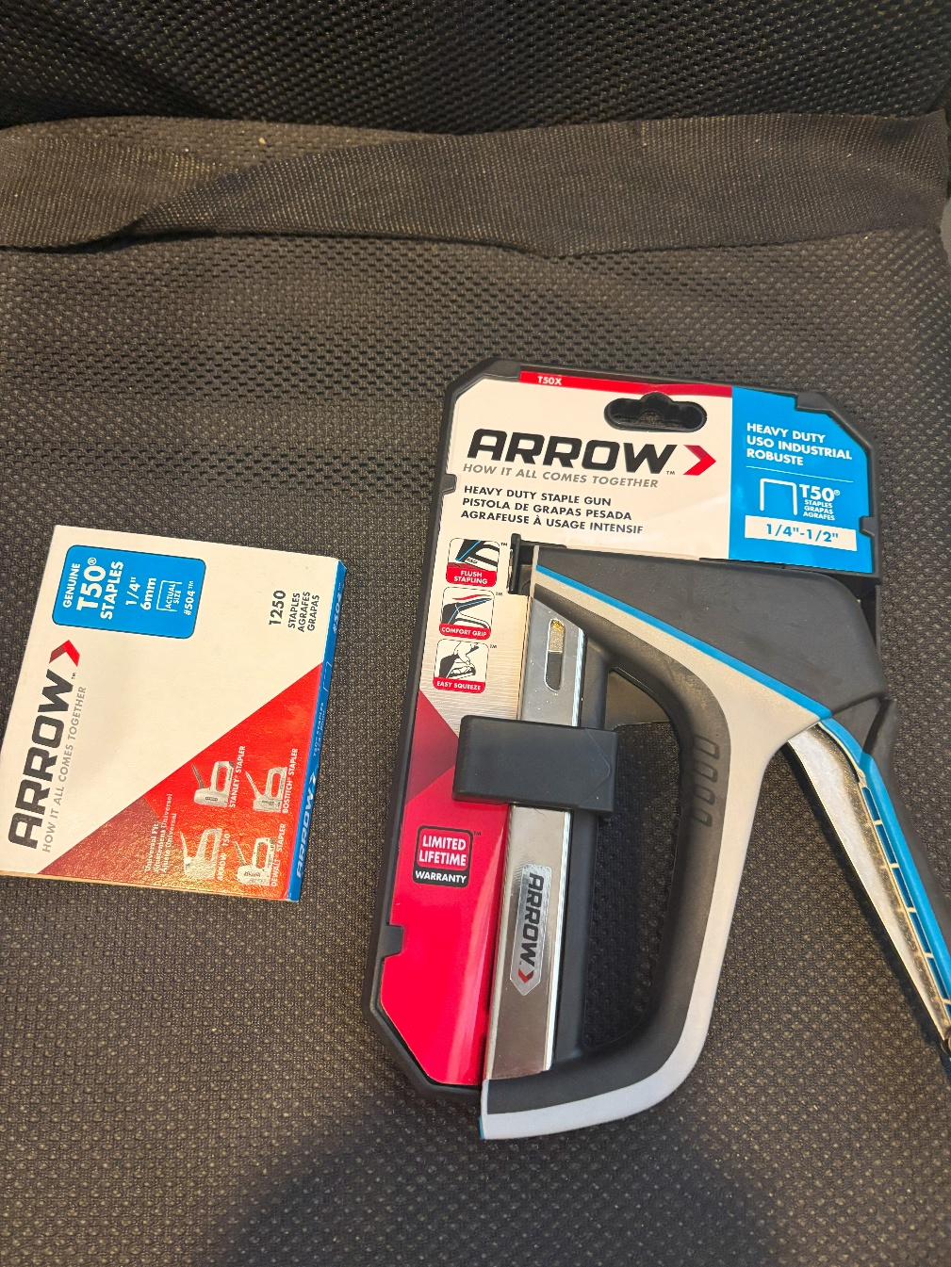

It is raining in the Bay Area. I will start the process of stapling posters on light posts. Next I will overlay them with my Nintendo Switch Korg music design app.

[0:00, Stapling] Call me tacky. Call me desperate. Call me bold. Call me crazy. Carry on with duct tape from Kamala. IU, I am loving you all around. Fluppy F-One is for you. Why are you so huggable?

[0:31, Stapling] Designed using Korg on Nintendo Switch.

* [Stapling promotional posters in light posts](https://www.youtube.com/watch?v=Oz7AG8BlcxE).

# F1 Movie

* [F1 Movie starring Brad Pitt](https://youtu.be/2zQtb0H1QEs?si=QLRSUQJuYtMDPa_u)
* Fuffy pillow.

# Run-on sentence

Lots of run-on sentences. Use hyphens for independent clause that beings with because. Never start with “but” because it is coordinating conjunction. Remember a **Basic Sentence** has a subject and a verb. A conjunction connects two Basic Sentence together. Always trace the **Basic Sentence**.

Another problem is that a sentence needs to be parallel by tracing the subject. All around, Chris you are not keeping track of the subject and verb. It is the core of a sentence. “If you don’t step in and live intentionally, the best you can hope…” should be “Don’t step in and live intention, if you can hope”.

# God Speak

* [I speak. You Speak. We All Speak For God Speak.](https://x.com/PeteHegseth/status/1900989848112021890)\

# NASA

The Ads is displayed on the billboard.

* [Anatomy up hers](https://x.com/elonmusk/status/1901655942954963102)

# Joe Rogan

* [Welcome. Yours truly.](https://x.com/teslaownersSV/status/1900395877208121863)

# Minecraft

You have to create in order to survive.

-Jack Black

# A letter from The Top Uber Driver

Dear,

Elon. As the top driver of your world-renowned Tesla, I love it all around. The one-pedal works like a charm in the top hills of San Francisco. However I’ve outlived “the girls” in the piano class in my days. I have recently upgraded to cutesy-Netflix-quality South Koreans. I must say: that the legroom is a non-starter.

* [The prayer has been meet](https://x.com/PlutusCosmos/status/1901797005745373193).

Ok, got it. My prayer has been met. My squirting days just got happier.

# Earthquake

At the moment of this writing, I’ve been hit with an earthquake.

China praises podcast

* [Lex Fridman's Podcast prompts China to work with India.](https://x.com/MeghUpdates/status/1901616580167164000)